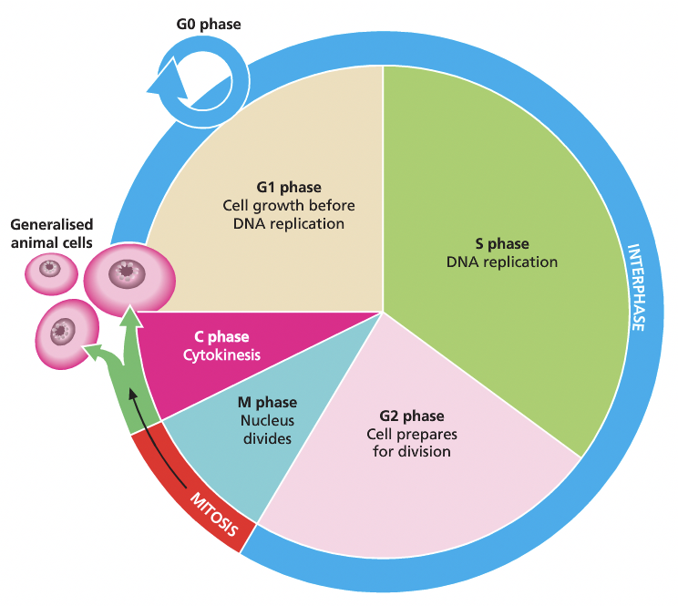
Heredity

Continuity of life requires the replication of genetic material and its transfer to the next generation through processes, including binary fission, mitosis, meiosis and fertilisation.
Mitosis
Interphase
- Stage between nuclear divisions
- G1 - Growth: copying of organelles
- S - Synthesises: a complete copy of DNA, centrosomes
- G2: more growth, reorganisation

Prophase
- Chromatin threads condense
- Spindle forms
- Spindle fibres attach to centromere of each chromosome
- Nuclear membrane breaks down

Metaphase
- Sister chromatids align on the metaphase plate
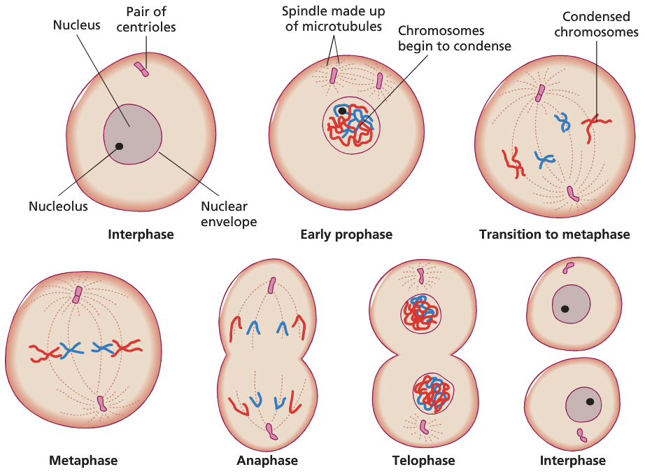

Anaphase
Spindle fibres contract, pulling sister chromatids to opposite sides of the cell

Telophase
Chromosomes de-condense
Nuclear membrane reforms
Spindle disassembles

Cytokinesis
Cleavage furrow is created
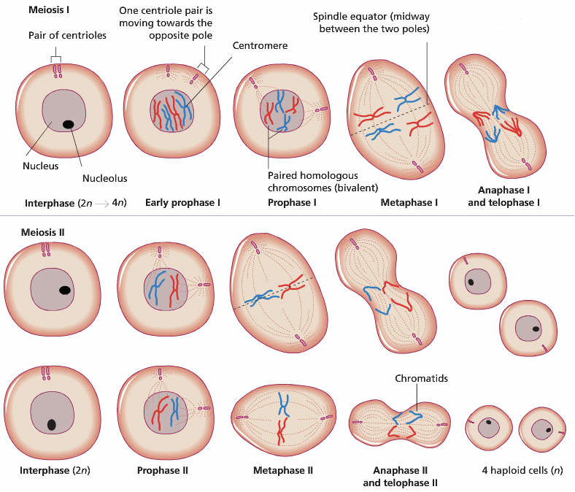
Meiosis

Prophase I
- Chromatin threads condense
- Spindle forms
- Spindle fibres attach to centromere of each chromosome
- Nuclear membrane breaks down
- Crossing over occurs

Metaphase 1
• Chromosomes align on equator of cell in random order
• Homologous chromosomes bond, one paternal one maternal

Anaphase
• Spindle fibres contract pulling chromatids to opposite poles of cell
- One side containing paternal/ maternal.
- The probability for which will be where is random due to random alignment order.

Telophase 1
- Chromosomes de-condesnse
- Nuclear membrane reforms
- Spindle disassembles

Cytokinesis completes the first stage of meiosis
Meiosis 2: The same processes occur in each stage, and finally in telophase the chromosomes de- condense and the new nuclear membranes form. Cytoplasmic division follows so that FOUR HAPLOID cells form from the original single diploid parent cell.


Comparing mitosis and meiosis

Mitosis | Meiosis
Growth and repair | Producing gametes
Somatic cells | Ovaries and testes
2 cells  With the diploid number of chromes | 4 cells  With the haploid number of chromosomes
No genetic variation | High genetic variation

Binary fission
Because bacteria have a single chromosomes, no nucleus and no centromere, the process differs
- Dna replicates
- Each copy of the chromosome attaches to a different part of the cell membrane
- When the cell begins to pull apart, the replicated and original are separated
They have identical genetic makeup

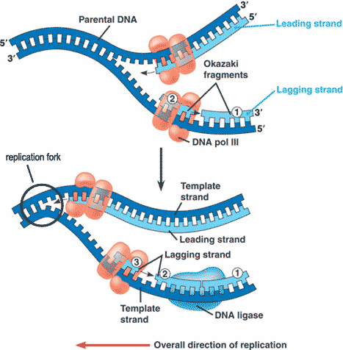
DNA Replication
- DNA helicase unzip the helix, separating the strands by breaking the weak hydrogen bonds, exposing bases along the replication fork.
- RNA Primase gives DNA polymerase a primer to start replication. RNA primers are necessary because polymerase can only extend existing DNA
- DNA polymerase then adds corresponding bases to the leading strand
- Okazaki fragments are joined by DNA ligase

Protein synthesis
Transcription (DNA to mRNA)
- Initiation: DNA helicase unzips the DNA, exposing the template strand
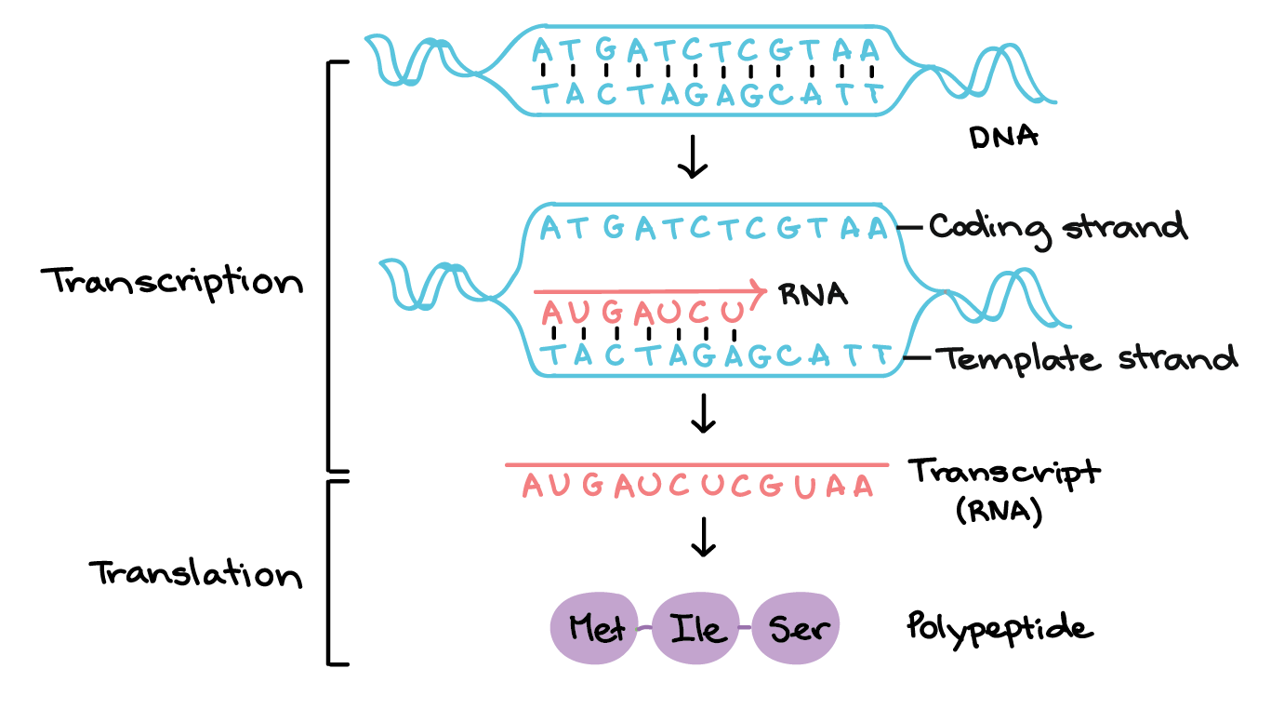
- Elongation: A particular sequence of nucleotides at the beginning of a gene called a promotor signals the start of a gene. RNA Polymerase binds to the promotor and complementary RNA nucleotides are progressively joined from RNA Polymerase
- Termination: A stop codon is reached, polymerase stops adding nucleotides
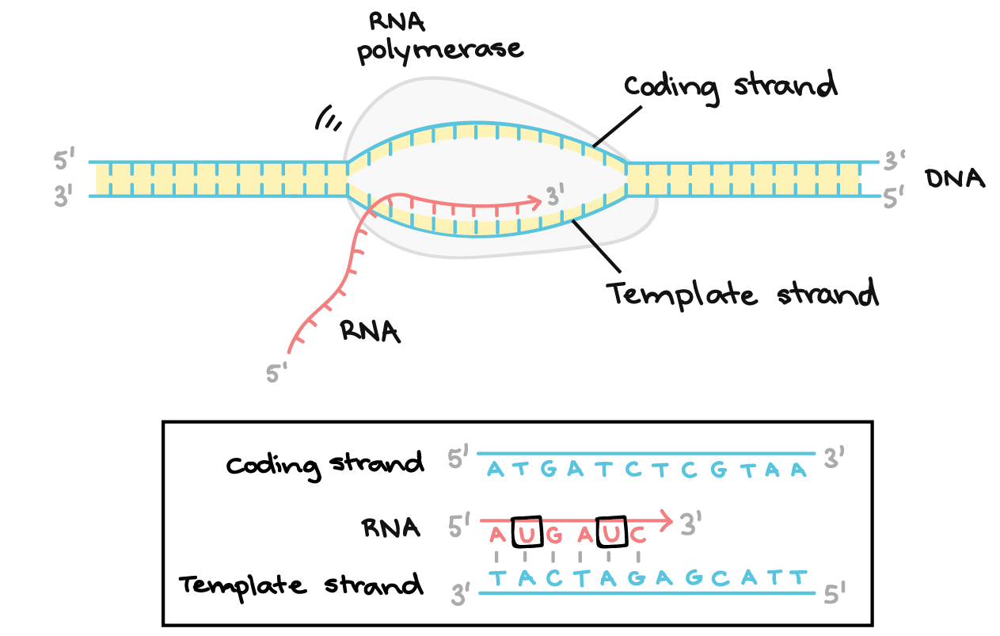

- Introns are genes that are not used for protein synthesis/not translated and are thus spliced out before leaving the nucleus. Exons are coding regions which contain information for protein formation.

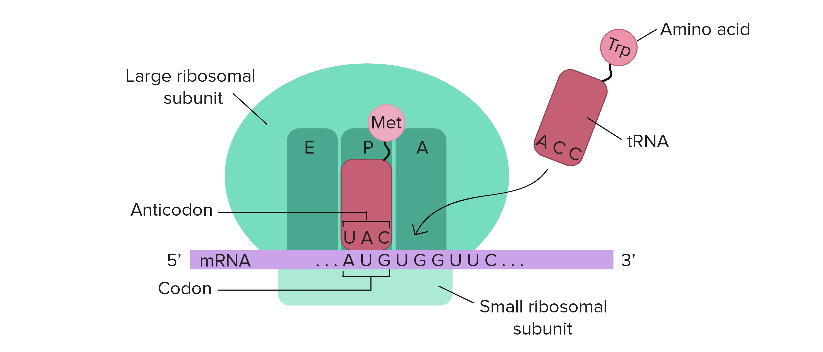
Translation
- Initiation: As mRNA moves into the cytoplasm it attaches itself to a ribosomal subunit. It will scan along the mRNA strand 5’3’ looking for a start codon (AUG). Once found the larger subunit also joins to the small one.
- Elongation: As the ribosome passes over the codons in the mRNA, a tRNA carrying the appropriate amino acid moves to the ribosome. The codon (3 bases) in the mRNA binds to the anticodon in the tRNA. The ribosome then moves onto the next codon,
- Termination: This continues until a stop codon is reached. The amino acids are now linked in according to the corresponding sequence of codons in mRNA.

Mutations
Errors in cell divine cause mutation
- Translation
- Transcription
- Dna replication
- Meiosis

Mutagens
- Physical - Radiation can break bonds during transcription or translation (eg UV light)
- Biological - invasive pathogens
- Chemical - Can affect DNA by swapping bases (eg mustard gas)

Genetic mutations
- Substitution - one nucleotide replaces another
- Insertion - addition if nucleotides
- Deletion - loss of nucleotides

These are frameshift mutation, the reading frame for the corresponding amino acids per codon has been shifted away from the original position, all codons downstream are affected. Consequence is the translated protein bears no resemblance to the original polypeptide chain

- Aneulploidy - When homologous chromosomes undergo non-disjunction during meiosis.
Two gametes receive two of the same chromosome, the other two receive non (eg 45 or 47 instead of the regular 26)
Variation
Crossing Over: During prophase of meiosis I, the homologous pairs of chromosomes cross over with each other and exchange chromosome segments.
  - This recombination creates genetic diversity by allowing genes from each parent to intermix, resulting in chromosomes with a different genetic complement.
  - The new combination of genes on a chromosome can lead to new traits in offspring.

Independent Assortment: During meiosis, the pairs of homologous chromosome are divided in half to form haploid cells, and this separation, or assortment, of homologous chromosomes is random.
  - This means that all of the maternal chromosomes will not be separated into one cell, while the all paternal chromosomes are separated into another. Instead, after meiosis occurs, each haploid cell contains a mixture of genes from the organism's mother and father.

Patterns of inheritance
Polygenes: A gene who’s individual effect on a phenotype is too small to be observed, but which can act together with others to produce observable variation.
  - This means that each dominant allele “adds” to the expression of the next dominant allele.
  - Usually traits are polygenic when there is a wide variation in the trait. For example, humans have many different sizes. Height is a polygenic trait, controlled by at least 3 genes with 6 alleles. If you are dominant for all the alleles for height, you are very tall.

Phenotypic expression
Regulatory genes
- A gene that codes for regulatory proteins.
- Activators bind to DNA, unwinding it from the histone proteins and exposing the gene for transcription.
- Repressor proteins bind to the promotor of a specific gene to block RNA polymerase from binding and thus prevent transcription.

Chemical modification
  - Acetylation: acetylation activates gene expression by releasing an enzyme that makes the DNA coil around his tones looser, allowing transcription and translation of protein synthesis to take place.
  - Methylation: does the opposite tightening the coiled DNA around the histones to prevent translation process of protein synthesis, therefore turning off / deactivating the even

Environmental factors
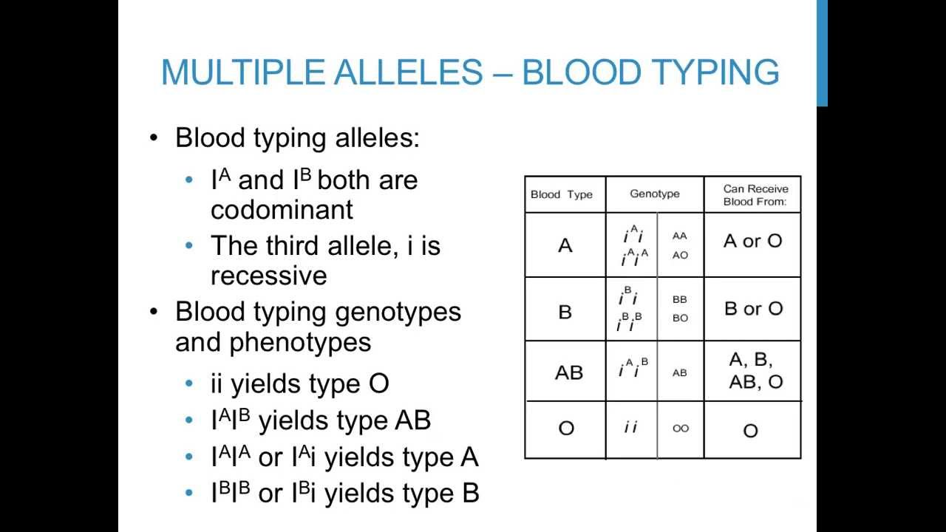
can activate/inhibit gene expression
- Temperature
- Light
- Chemicals in food

Multiple alleles
- Multiple alleles exist in a population when there are many variations of a gene present. In organisms with two copies of every gene (diploid organisms) each organism has the ability to express two alleles at the same time.

Test Cross:
- To identify whether an organism exhibiting a dominant allele is homozygous or heterozygous for a specific allele, a scientist can perform a test cross.

- The organism in question is crossed with an organism that is homozygous recessive for that same trait, and the offspring of the test cross are examined - If the offspring produce any recessive traits, it indicates the organism in question is heterozygous.

— Biotechnology
Restriction Enzymes:
- RE only cut specific sequences of DNA, known as ‘restriction sites’. Different RE have different restriction enzymes have different restriction sites.
- The cuts may form either sticky ends, which leave some nucleotides exposed or blunt ends where the cut has occurred at the same position in each strand.

Genetic Cloning:
An alternative to PCR which has many advantages, it allows replication of large DNA segments and permits the analysis of any gene and associated proteins.
- Plasmids are extracted from bacteria by rupturing the cell walls
- Using restriction enzymes, the desired DNA is cut to create sticky ends, the same RE is then used to cut the plasmid so those same complimentary bases will be exposed and they bond together
- DNA ligase binds the ‘foreign DNA’ fragment into the plasmid DNA. After binding, the DNA
fragment becomes a permanent part of the recombinant plasmid.
- The recombinant plasmids are added to a bacteria culture. They are taken up by some bacteria
in which they replicate. In the normal process of growth and division, bacteria replicate the plasmid and thus numerous copies of the incorporated foreign DNA are made

Restriction enzyme: An enzyme used to cut DNA at a recognition site. It is also used to cut the host DNA in order to allow the fragment to be spliced onto the host.
Ligase: Enzyme used to join fragment of DNA to recipient DNA. Can also link to segments or complimentary strands of DNA
Plasmid: Circular shaped double stranded DNA that is not chromosomal obtained from a bacterium onto which the DNA fragment is spliced.
Plasmids are used as vectors in recombinant DNA technology.
Vector: Plasmid molecule which contains the recombinant DNA that is incorporated

Gel Electrophoresis:
A technique that separates DNA based on size and charge.
- DNA has a net negative (-) charge due to the phosphate groups in its backbone.
- Wells are created using a plastic comb into the gel as it sets, creating indentations into which the DNA can be loaded.
- The gel is placed in a tray filled with a buffer solution, and positive and negative electrodes attached to each end of the gel.
- The DNA is placed in the end closest to the negative electrode, therefore the negative current causes the DNA to repel from it.
- The gel acts as a large sponge through which the DNA will move while under the influence of an electric current. Smaller strands can wiggle through the gel matrix faster than large strands, which take longer to migrate than larger strands through the gel. Longer DNA is hence closer to the negative electrode.
- Dye is added showing a band pattern which can then be photographed. Each band represents millions of DNA pieces that are the same size. The position of bands on an agarose gel depends on the size, to determine that size of a given piece of DNA, molecular size markers are used.
DNA Profiling:
Identifies an individuals specific DNA profile
Short tandem repeats are sections of non-coding DNA that are repeated many times. The repeat is present in all members of the population, but the number of repeats varies between individuals. Each individual has 2 alleles for each STR, one from each homologous chromosome (mother/father)
- A DNA sample is collected from an organism
- Amplified/copied using PCR
- The amplified sequences are placed on gel electrophoresis to produce a banding pattern
Used in fingerprinting,
DNA Sequencing
Sanger Sequencing: This is a procedure that determines the precise order of nucleotides in a sample of DNA. Nucleotides bond to one another on the 3’ hydroxyl group from the previous nucleotide.
Sanger sequencing removes the hydroxyl group from nucleotides, creating dideoxynucleotides (ddTP) that disallow the continuation of DNA synthesis. This allows the base sequence of a particular length of DNA to be known. Sanger sequencing requires
- Radiactively labelled primers
- Normal nucleotides
- DNA sample being tested
- ddTP nucleotides
- DNA Polymerase
Four separate test tubes containing each of the four bases of ddTP nucleotides are created with these elements. DNA Polymerase will act on the primer and the sample DNA and will use free nucleotides in synthesising new DNA strands. Upon using a ddTP nucleotide, the synthesis will halt. DNA Polymerase will then bind to another primer and continue until reaching another ddTP nucleotide and so on. This creates different lengths of DNA that end in a particular base. These different lengths can be separates by gel electrophoresis to determine the nucleotide sequence as the different lengths will travel down the gel plate at different speeds. The position each fragment stops relative to the other four bases determines its DNA sequence.
PCR:
Eukaryotic cells only have 2 copies of DNA, prokaryotic cells have 1 copy. This is a problem for scientists. PCR increases amount of DNA available.
- Denaturation: Double stranded DNA is heated to 95oC, breaking the hydrogen bonds causing the strands to denature (become single stranded)
- Annealing: Temperature reduced to 50oC-60oC, so the synthetic primers can attach to the 3’ end.
- Extension: Temperature is increased to 72oC, the optimum for taqDNA Polymerase. Now there are 2 copies of single stranded DNA.
Cycle is repeated. Each cycle doubles the amount of DNA produced.

Continuity of life on earth

Convergent evolution: When 2 different species do not share a common ancestor but have developed similar characteristics through adaptation to similar environmental conditions.

Divergent evolution: Occurs when two different species share a common ancestor but have different characteristics of each other. It is when one ancestral species diverse into multiple descendant species.

— Evidence for evolution
Comparative Structures

Embryology: All members of phylum Chordata have at some stage of development; • Dorsal notochord (solid tissue running along back)
• Pharyngeal slits (turn into gill slits into fish)
• Dorsal nerve chord
• Tail that extends past the anus
The similarities observed between embryos of fish, humans and many other organisms are suggestive of a shared ancestor from which all these species have evolved.
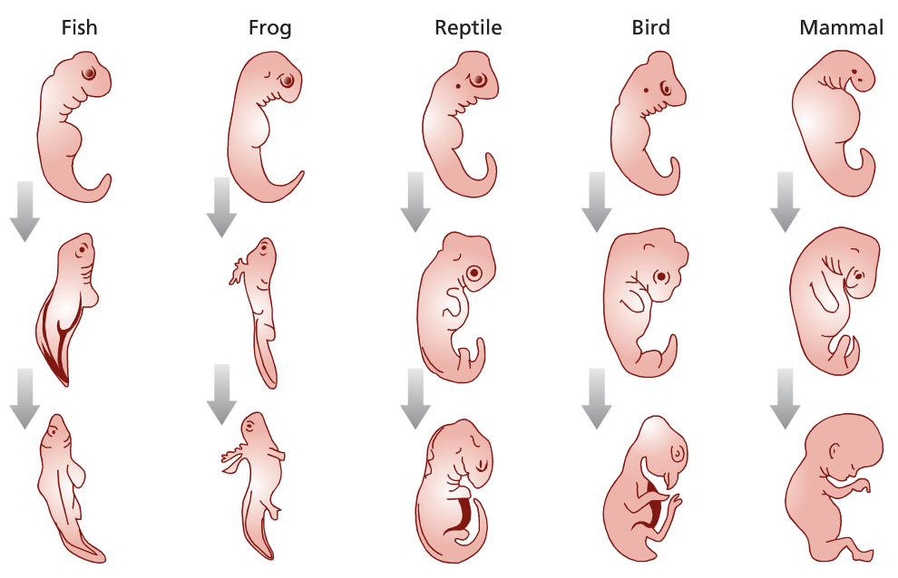
Homologous Structures: Common physiological structures shared by different organisms that stem from their descent from a common ancestor
- The wing of a bird, wing of a bat, leg of a crocodile, flipper of a whale and arm of a human all have the same basic structure; the pentadactyl wing.
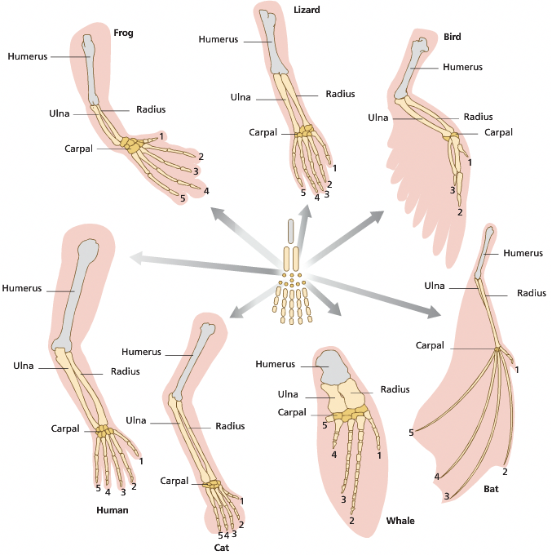
Vestigial Structures: A homologous structure from a common descent that ceases to provide a functional use for an organism.
- In humans we have our appendix, which appears to be the shrunken remains of the caecum; a far more extensive structure found in the digestive tract of herbivorous primates used to digest cellulose.

Analogous Structures: Structures that have the same function but not the same basic structure
- The eyes of octopi and vertebrates are very similar. In vertebrate eyes however, the nerve fibres lie in front of the sensory cells in retina, wheres in octopi they lie behind them. Vertebrates therefore have a blind spot, octopi do not.

Molecular evidence
Protein conservation: Two distantly related species may share similar protein sequences, meaning they could share a common ancestor.
Genetic comparison: Mutations may arise in non- coding sections of DNA. The frequency of neutral mutations is called the mutation rate. When comparing two species genomes, the mutation rate can be used as a molecular clock to estimate the point two species diverged from a common ancestor.
DNA Hybridisation: Provides a way to compare genomes of different species by measuring the degree of genetic similarity between DNA sequences.
- DNA from the two species to be compared is extracted, purified and cut into short fragments
- The DNA of one species is mixed with the DNA of another
- The mixture is incubated to allow DNA strands to dissociate and reanneal, forming hybrid
double stranded DNA.
The hybridised sequences that are highly similar will bind more firmly. A measure of the heat
energy required to separate the hybrid stands provides a measure of DNA relatedness
Fossil Record
Relative Dating: By using index fossils you can estimate the age of a fossil within strata. A useful index fossil must be distinctive or easily recognisable, abundant, and have a wide geographic distribution and a short range through time.

Absolute Dating:
• Radioactive dating
• Electron spin resonance

Limitations in fossil record
- Incomplete fossils
- Not all organisms had representatives in the fossil record • Not all conditions produce fossils of organisms remains
— Therefore there are many organisms not yet discovered

Natural Selection
Natural selection occurs when selection pressures in the environment confer a selective advantage on a specific phenotype to enhance its survival and reproduction; this results in changes in allele frequency in the gene pool of a population over time.

Principles of Natural Selection:
1. Individuals differ from one another; variation within a population
2. Many of these variations are caused by mutations in DNA and are inheritable
3. In general, more offspring are produced than can survive to maturity and reproduce. Because
of this there is a struggle for existence and only some can reproduce.
4. Some individuals have traits that make them more suited to their environment than others,
making them better able to reproduce and pass their alleles on to a next generation
Selection Pressures
• competition between species for food and territories
• predator-prey relationships
• competition within species for food or water
• competition within species for territories or nesting places
- sexual selection
A form of selection where individuals with certain inherited characteristics or behaviours are more likely than others to obtain mates and pass on their genes.

— Evolution
Microevolution: Refers to any change in the gene pool of a variation. The significant outcome of natural selection pressure is a change in the frequency of various alleles within a population.
Macroevolution: Major evolutionary changes above the species level of taxa. This is a rare occurrence and usually due to extreme geological events.

Genetic Drift: is a mechanism of evolution in which allele frequencies of a population change over generations due to chance (sampling error).
Each individual inherits half of their alleles from the mother and half from the father. Which half of their respective parents alleles is passed onto the offspring is a matter of chance (independent assortment).
Migration and gene flow: The transfer of alleles or genes from one population to another. Gene flow may occur if migrants breed. Immigrants may add new alleles, emigrants may remove or change the frequency of alleles.
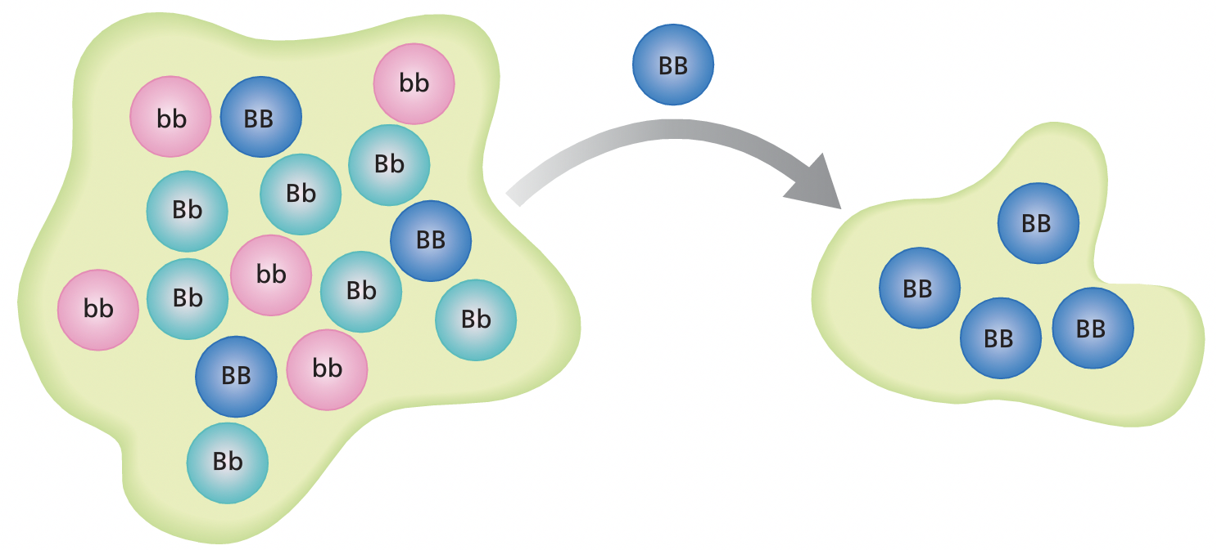
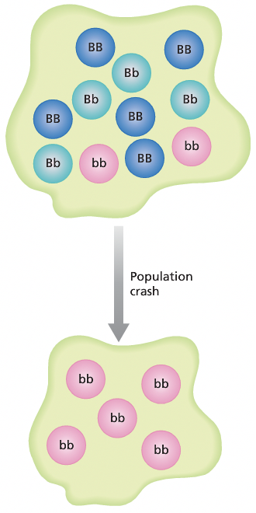
The founder effect: Individuals who move to a new area and become isolated from a larger population might not carry all alleles that were present in the original population. This results in less genetic diversity and deleterious recessive alleles may have a higher chance of coming together than in the original population.

Bottleneck effect: occurs when there is a disaster of some sort that reduces a population to a small handful, which rarely represents the actual genetic makeup of the initial population. This leaves smaller variation among the surviving individuals.
It occurs when the true frequency of alleles of a certain population, is not accurately presented in the new population.

Pre- reproductive isolating mechanisms
Some isolating mechanisms prevent organisms from being able to interact to reproduce.
- Geographical: individuals are separated by geographic features such as seas, mountains, distance or habitat
- Temporal mechanisms: individuals breed during different seasons of the year or times of the day
- Behavioural mechanisms: individuals have different courtship patterns
- Morphological mechanisms: individuals have different reproductive structures that make mating physically impossible
Post- reproductive isolating mechanisms
If a frog does accidentally mate with a frog from another species, they will not produce fertile, viable offspring because the parents chromosomes cannot line up successfully during meiosis, and no zygotes are formed. These methods are called post- reproductive isolating mechanisms. They do not prevent mating from occurring but they do prevent young from being produced, they include;
- Gamete mortality: the gametes do not survive
- Zygote mortality: the zygote forms but does not survive
- Hybrid sterility: adult offspring are formed but are infertile because they are unable to produce viable gametes, usually as a result of a different number or structure of chromosomes from each species.
Speciation
Allopatric speciation: The result of populations becoming physically separated through geographical isolation, leading to the disruption of gene flow.
Sympatric speciation: The evolution of 2 or more species from a single population within the same place. This can occur because they mate at different times, eat different food or sexual selection.

Homeostasis
Homeostasis is the process by which the body maintains a relatively constant internal environment; it involves a stimulus‐response model in which change in external or internal environmental conditions is detected and appropriate responses occur via negative feedback
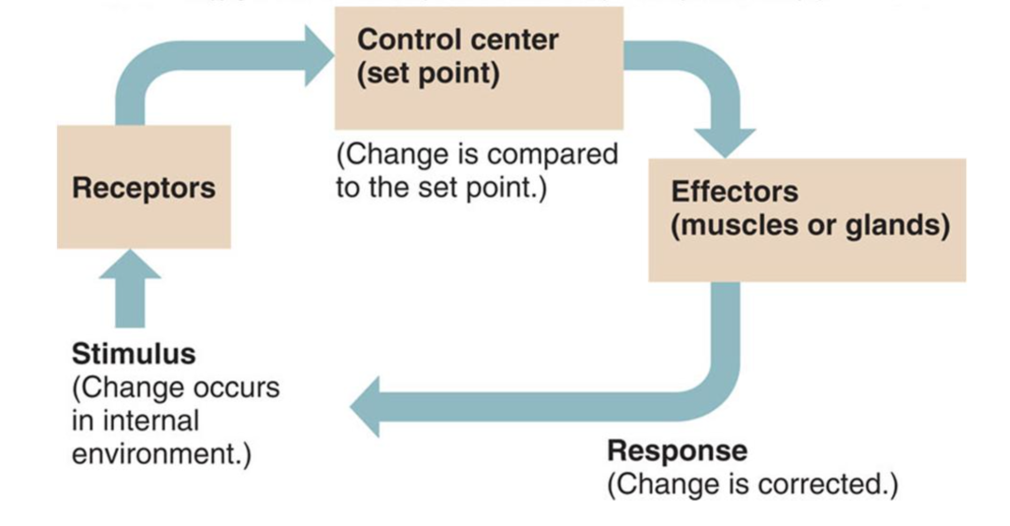
Homeostasis: The maintain of a relatively constant internal environment, maintains despite fluctuations in the external environment.

—> Stimulus response model
- Stimulus: change to internal or external conditions
- Receptors: specialised nerve endings that detect the change
- Modulator: coordinates the response
Effector: organ or gland that carries out the response Response: the action by the effector

—> Systems
Nervous system: Composed of nerve fibres split into the central and peripheral nervous system
  - CNS: Made of the brain and spinal cord - responsive for processing, storing and coordinating information
  - PNS: Is made of all the other neutrons, it is responsible for transmitting info to and from the CNS
Endocrine system: Slow control compared to the nervous system. Produces hormones that are secreted by glands into the bloodstream. Only cells that have particular receptors will reason to a particular hormone.

 | Nervous | Endocrine
Speed | Fast | Slow
Duration | Short | Long
Travel via | Nerves | Bloodstream
Signal | Electrochemical | Chemical

—> Receptors
  - Exterocpetors: receive signals from the external environment
  - Introceptors: receive signals from the body’s internal environment

—> Feedback
Negative feedback loop: is a process in which the body senses a change, and activates mechanisms to reverse that change. Controls the rate of a process to avoid accumulation of a product.
Positive feedback loop: this is when a change starts, the nervous system recognises the change, and then stimulates more hormones to accelerate the change. The rate of a process increases as the concentration of the product increases. (less common)

Metabolic activity
Changes in an organism’s metabolic activity, in addition to structural features and changes in physiological processes and behaviour, enable the organism to maintain its internal environment within tolerance limits (temperature, nitrogenous waste, water, salts, and gases)
Metabolic activity: The sum of all the chemical reactions that occur in an organism to maintain life
  - Most reactions requite enzymes (which function at specific pHs/Temperatures)
  - Metabolic activity creates internal body heat; increased activity results in increased temperature
  - These aspects are all connected;
      - eg) An increase in CO2 —> a decrease in pH —> a decrease in enzyme function —> a decrease in metabolism —> decrease in internal body temperature

- Structural: structures of an organism that aid survival through homeostasis
- Physiological: functions, chemical reactions and processes eg. Reabsorption of water
- Behavioural: actions carried out by the organism eg burrowing, huddling, curling

Tolerance limits: the set range in which different levels of materials, pressure and temperature can be tolerated. Homeostasis maintains levels within an optimum range - if it fails and tolerance levels are exceeded the organism will fall into a state of physiological stress.
Adaptions: Organisms adapt to their environment to maintain their internal environment.

—> Need for maintenance
Gases:
  - CO2 affects the rate of phtosynthesis/ decreases the pH of blood
  - O2 affects the rate of respiration and is required for aerobic respiration
Nitrogenous waste: Toxic and reduce reaction rates if left to accumulate
Temperature: Affects reaction rates and can denature essential enzymes
Water: dissolves and transports substances used in temperature control
Salts: Affect osmotic pressure and stomatal control

Thermoregulation
Thermoregulatory mechanisms include structural features, behavioural responses and physiological mechanisms to control heat exchange and metabolic activity; animals can be endothermic or ectothermic
Thermoregulation: the maintenance of a fairly steady body temperature even under a variety of external conditions. Heat comes from chemical reactions. Both endotherms and ectotherms require homeostasis to maintain temperature.

—> Need for maintenance
Conduction: Heat transfer via direct contact
Convection: Heat transfer via movement of air and water
Radiation: Heat transfer via transfer of heat by infrared rays
Evaporation: Heat transfer via liquid changing into liquid vapour

Endotherms: Animals which use metabolic heat to increase temperature to suitable levels. They maintain their temperature with narrow limits by controlling heat loss.
Ectotherms: Use environmental heat to increase body temperate to suitable levels. They control heat gain.

 | Ectotherms | Endotherms
Advantages | - Use less food in respiration  - May survive long periods with eating  - Greater proportion of energy obtained from food can be used for growth | - A fairly constant body temperature despite external environment  - Activity still posible  - Ability to inhabit colder climates
Disadvantages | - Less active during colder seasons, early morning, evening etc - making them more susceptible to predation  - Need sufficient stores of energy/food to survive colder climates/seasons  - Unable to increase reputation rates to generate heat | - Significant part of energy intake must be used to maintain temp in colder/warmer climates  - More food required  - Less energy can be used for growth

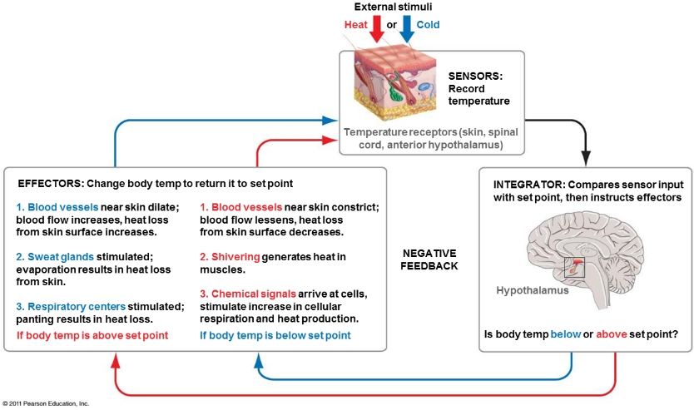
—> Stimulus response model for temperature

—> Behavioural strategies
- Elephants spray themselves with water to cool down on a hot day
- Many animals seek shade when they get too warm
- Lizards bask on a hot rock to warm up
- Penguin chicks huddle in a group to retain heat.

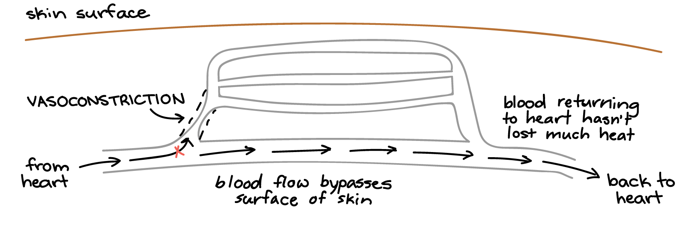
—> Physiological
Vasoconstriction: In endotherms, warm blood from the body’s core typically loses heat to the environment as it passes near the skin. Shrinking the diameter of blood vessels that supply the skin reduces blood flow and helps retain heat.
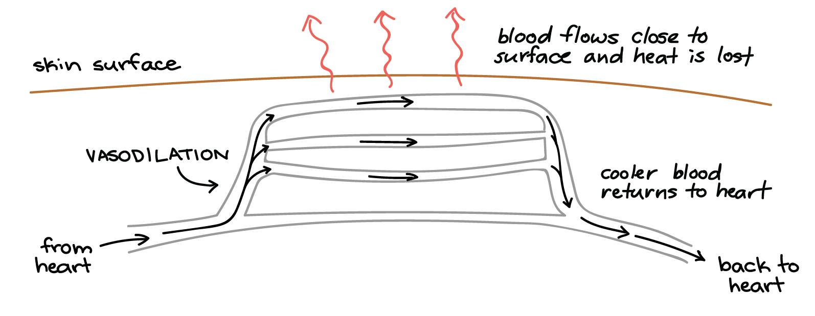
Vasodilation: when an endotherm needs to get rid of heat these blood vessels get wider, or dilate. This increases blood flow to the skin and helps the animal lose some of its extra heat to the environment.

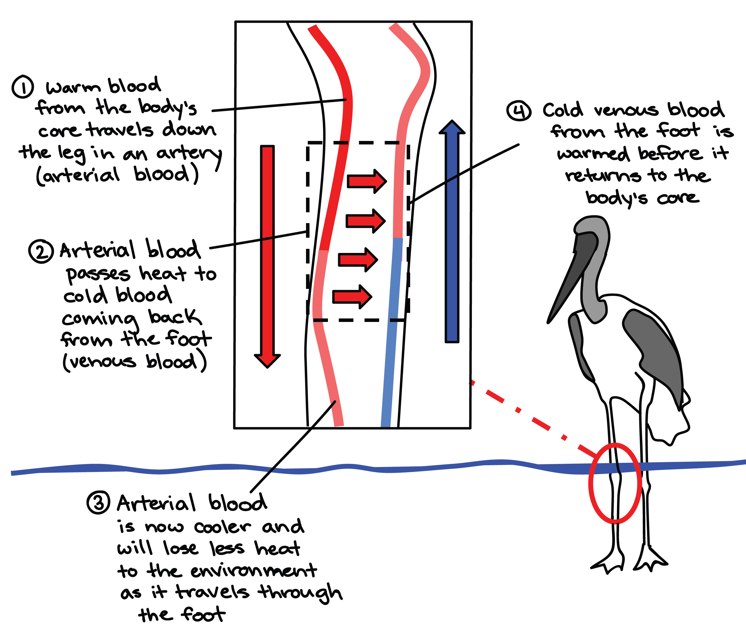
Countercurrent heat exchange:
Many birds and mammals have countercurrent heat exchangers, circulatory adaptations that allow heat to be transferred from blood vessels containing warmer blood to those containing cooler blood.

In the leg of a wading bird, the artery that runs down the leg carries warm blood from the body. The artery is positioned right alongside a vein that carries cold blood up from the foot. The descending, warm blood passes much of its heat to the ascending, cold blood by conduction. This means that less heat will be lost in the foot due to the reduced temperature difference between the cooled blood and the surroundings and that the blood moving back into the body's core will be relatively warm, keeping the core from getting cold
—> STRUCTURAL
- Fur and blubber - Trap a layer of air next to the skin and reduce heat transfer to the environment
- Extra e.g.) Polar bear hairs are porous, absorbing water when wet - acting like a wetsuit! Their skin is also black beneath their fur, allowing them to absorb heat through radiation.

Waste
The type of nitrogenous waste produced by different vertebrate groups can be related to the availability of water in the environment.
Nitrogenous waste: Breakdown of proteins from amino acids results in nitrogenous waste.

Toxicity: is related to the amount of water in the environment.
Nitrogenous waste products have their origin in the breakdown of proteins by cells. Cells catabolize amino acids to obtain energy. The first step of this process is deamination. During deamination, enzymes remove the amino group as ammonia (NH₃).

Water:
- Ammonia requires lots of water to be expelled as a dilute form
- Ulric acid has barely any water.
- Urea has some but does not require as much as ammonia

Energy: It requires more energy to make uric acid and urea than it does to produce ammonia.

Reproduction: reptiles and birds stay in their eggs for extended periods of time, if they produce urea or ammonia it would kill the baby as the egg is not permeable. Amphibians and fish however have slightly permeable eggs and are submerged.

Ammonia: Ammonia is toxic, even at low concentrations, and requires large amounts of water to flush it out of the body.
Urea: Many animals, including humans, create a less poisonous substance, urea, by combining ammonia with carbon dioxide. An animal can retain urea for some time before excreting it, but it requires water to remove it from the body as urine.
 | Toxicity | Solubility | Energy | Example
Ammonia NH3 | High | High | Low | Fish
Urea (NH3)2CO | Medium | Medium | Medium | Humans
Uric acid C3H4N4)3 | Low | Low | High | Birds and reptiles
Uric acid: Birds, insects, land snails, and most reptiles convert ammonia into an insoluble substance, uric acid. This way, water is not required water to remove urea from the body.
- Fish are constantly exposed to water meaning they can constantly expel ammonia while birds, reptiles, etc have to store nitrogenous waste for longer periods as the most toxic nitrogenous waste, it kills cells that store it.
- Terrestrial animals: Non desert dwelling terrestrial animals excrete urea. This is because it is the middle ground in terms of properties between ammonia and uric acid. It’s toxicity is moderate, its level of solubility is moderate and its energy required to synthesise is moderate. This is beneficial to many non desert dwelling animals. As they have adequate access to water, they can have enough for urea to remain soluble within.
- Desert dwelling animals however produce uric acid as their nitrogenous waste. This is because it requires no water as it is insoluble. This is beneficial as water is a very finite source in their environment

Osmoregulation
Animals have a variety of behavioural, physiological and structural adaptations to maintain water and salt balance in terrestrial and aquatic environments.

- Osmoregulators: Regulate their osmotic concentration independent of the external environment, using structural, behavioural and physiological responses to aid water balance.
- Osmoconformers: Allow their osmotic concentration to be equal to the concentration of the external environment
And lose water through:
- Urine
- Respiratory surfaces
- Evaporation from body surfaces
Vertebrates: Gain water through
- Drinking
- Eating
- Metabolic activity

—> Physicological
Desert dwellers:
- Long loops of henle to increase the amount of water reabsorbed by kidneys
- Water is reabsorbed by cloaca
- Ulric acid - nitrogenous waste (requires no water)
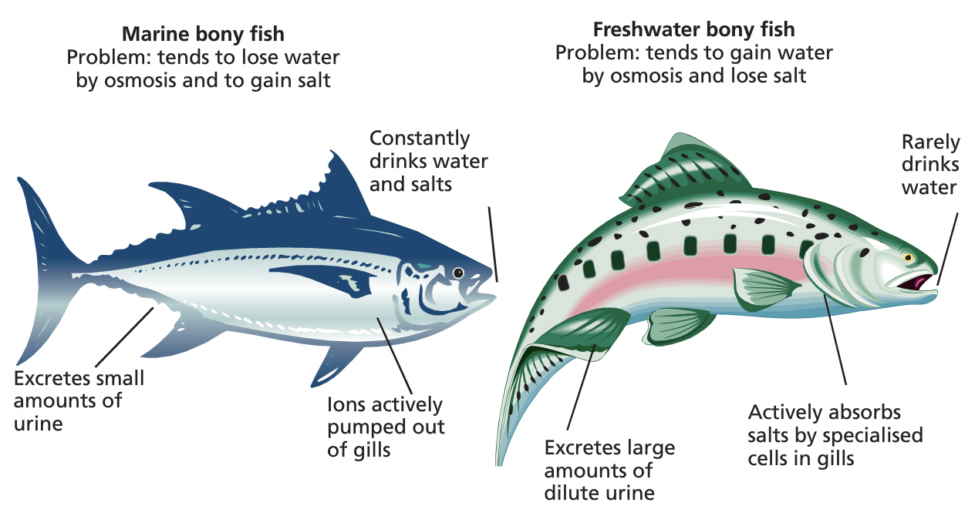
- Produce water by metabolising fat
- Reduce rate of urine production

Reptiles and insects:
- Hard outer coverings to stop evaporation.

Marine fish
- Constantly drink water
- This is - because there are more salts in the water than outside the body of the fish, salts will passively diffuse out.

- Excretes a small amount of highly concentrated urine

Freshwater fish
- Rarely drink water
- Because the salt levels in its body is higher than that of the surroundings, water diffuses into the bloodstream via the gills due to osmosis
- To increase the salt concentration inside its body. Chlorine pumps actively transport salts into the bloodstream
- Excretes large amounts of dilute urine

—> Behaviours of osmoregulatory
Burrowing: desert animals will burrow where the temperature is lower and humidity higher so water loss is reduced as there is less evaporation
- The desert hopping mouse has a bushy end to its tail, which it wraps around its face. This reduces water loss by saturating the air between the hairs at its body surface and the air in the burrow with water vapour.
—> Behaviours of osmoconformers
Most marine invertebrates are osmoconfromers
They are said to be isotonic with their surroundings as their osmotic concentrations are equal to their external environment
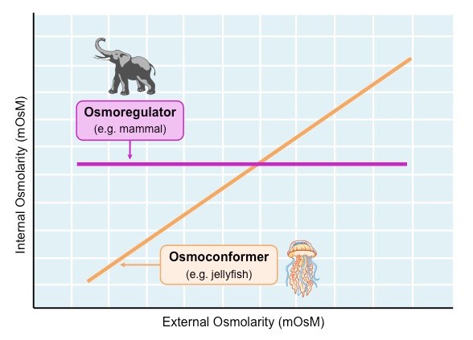
- Cartilagenous fish (like sharks) are able to concentrate urea and store it for longer (as it is less toxic than ammonia) in their bodies to maintain a high osmolarity - so they do not lose or gain water by storing it in their cells and circulating it in their blood.
- Urea acts as a type of solute and can be stored up so water does not move out of organism via osmosis to the surrounding environment - which usually has a higher solute concentration.

Plants
To maintain water balance and allow for gas exchange, xerophytes and halophytes have a variety of structural and physiological adaptations.
—> Xerophytes: Are adapted to live in dry conditions
Adaptions
- Reduced leaves: reducing the total number and size of leaves will reduce the surface area that water may belts from
- Rolled leaves: rolling up leaves reduces the exposure of stomata to the air - also preventing evaporation
- Thick, waxy cuticle: thickened cuticle prevents water loss from the leaf surface
- Stomata pits: surrounded by liars traps water vapour, reducing transpiration
- Low growth: low growing plants are less exposed too wind and more likely to be shaded
- CAM physiology: plants with CAM physiology open their stomata at night, reducing water loss via evaporation

—> Halophytes: adapted to saline conditions
Adaptions
- Cellular sequestration: halophytes can sequester toxic ions and salts within the cell wall or vacuoles.
- Tissue partitioning: plants may concentrate salts in particular leaves, which they then drop off.
- Salt excretion: certain parts of the pant (eg stem) may contain salt glads - which actively eliminate salt
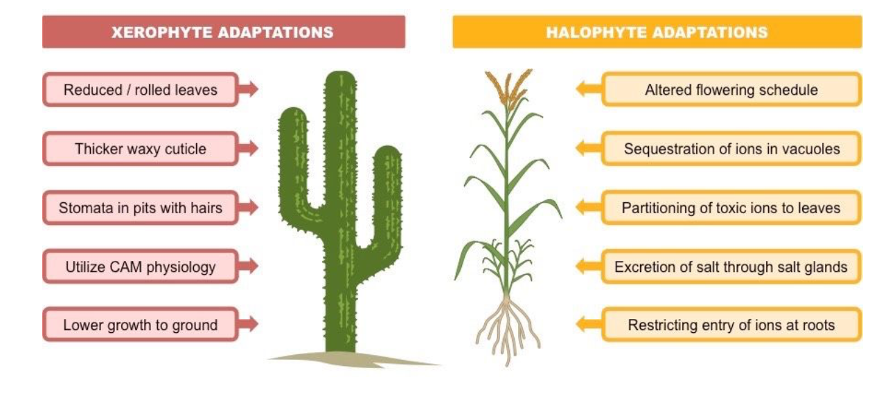
- Altered flowering schedule: may flower at specific times, like doing the rainy season to minimise salt exposure.

Diseases

Organism groups
The major groups of organisms that cause disease are bacteria, fungi, protists and viruses; each group can be distinguished by its structural characteristics

Pathogen Type | Plasma Membrane | Organelles/ structure | Reproduction
Virus  All viruses cause disease. | No, non-cellular organism.  Needs a host cell to survive which limits research. | No, composed of a core of DNA or RNA surrounded by a protein coat that can invade living cells. | Obligate cells. can only reproduce by infecting living cells.
Bacteria  Can survive in tougher dormant from = endospore | Yes, unicellular microscopic organisms. | No, prokaryotic. Bacteria may have flagellum/s (tails of movement). | Asexual/ Binary Fission
Fungi  Most are external infections of the skin. | Yes, cell walls contain chitin rather than cellulose. multicellular | Yes, Eukaryotic. | Asexual (Fragmentation, Budding, spores ) Spores are long lived.
Protists  No effective treatments. | Yes, defining feature is that it is a unicellular eukaryote without chitin in its cell wall. | Yes, Eukaryotic. | Asexual and Sexual

Modes of transmission
—> Modes of transmission
Direct contact: Pathogen is transmitted from one host to another when the skin of the 2 hosts come into direct contact.
Eg cold sores, chicken pox and Staphylococcus aureus.

Foodborne: Enter the bloodstream through the gastrointestinal tract. Ma be passed by touch, sneezing or coughing.
Waterborne: Disease can be spread while bathing, washing or drinking water, or by eating food exposed to infected water.
Airborne:. If a person sneezes airborne droplets, these aerosols can be carried large distances in the air.
Vector: A vector is a living organism that transmits pathogens from one host to another. Sometimes the pathogen is dependent on the vector for the completion of its life cycle. Using a vector is an important adaptation for transmission because a pathogen may not otherwise be able to come in contact with a new host, as it may not be able to penetrate the outer defences of a host in a way that would not be possible unassisted.

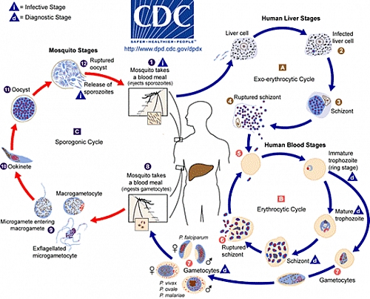
Diseases

—> Malaria
- Malaria infection begins when an infected female Anopheles mosquito bites a person, injecting Plasmodium parasites, in the form of sporozoites, into the bloodstream.
- The sporozoites pass quickly into the human liver.
- The sporozoites multiply asexually in the liver cells over the next 7 to 10 days, causing no symptoms.
- In the bloodstream, the merozoites invade red blood cells (erythrocytes) and multiply again until the cells burst. Then they invade more erythrocytes. This cycle is repeated, causing fever each time parasites break free and invade blood cells.
- Some of the infected blood cells leave the cycle of asexual multiplication. Instead of replicating, the merozoites in these cells develop into sexual forms of the parasite, called gametocytes, that circulate in the blood stream.
- When a mosquito bites an infected human, it ingests the gametocytes, which develop further into mature sex cells called gametes.
- The fertilized female gametes develop into actively moving ookinetes that burrow through the mosquito's midgut wall and form oocysts on the exterior surface.
- Inside the oocyst, thousands of active sporozoites develop. The oocyst eventually bursts, releasing sporozoites into the body cavity that travel to the mosquito's salivary glands.
- The cycle of human infection begins again when the mosquito bites another person.

—> Malaria
Host: Human (Anopheles mosquito acts as vector)
Pathogen Group: Parasitic protozoans (P rotists)
Symptoms of infection:
○ Headache, fever, shivering, joint pain, vomiting, hemoglobin in the urine, retinal damage, convulsions, anaemia
○ Incubation period approximately 10 days
Method of transmission:
○ The Anopheles mosquito bite introduces the parasites from the mosquito's saliva into a person's blood. (indirect vector)
○ Blood transfusion
○ From mother to child before and or/during birth
Management strategy:
○ Treatment chloroquine and other drugs
○ Preventative (prophylaxis) antimalarial drugs for humans
○ Problems with treatment include resistance to preventative drugs and the
absence of a vaccine
○ mosquito nets and insect repellents
○ draining stagnant water (disrupting the vectors life cycle)
Favourable conditions: Humid, warm, area with large number of stagnant water
areas.

—> Tuberculosis:
Host: Humans and cattle
Pathogen Group: Bacterium (Mycobacterium tuberculosis)
Bacteria infects the lungs and causes tuberculosis. Alveolar macrophages ingest
bacteria but are unable to destroy it. The bacteria then multiplies inside the
macrophage and when activated, destroys the macrophage.
Symptoms of infection:
○ (most people have inactive form/ latent which shows no symptoms)
○ Chronic cough that lasts for more than 3 weeks, Fever, night sweats, mmmm
unexplained weight loss, constant fatigue, loss of appetite, blood stained
sputum
Method of Transmission:
○ Aerosols released when someone with active TB sneezes, coughs or speaks.
○ Those aerosols are then breathed in infecting other individuals
○ Not spread via fomites simply spread in the air.
Management strategy:
Quarantine
6 month Drug treatment (antibiotics)
Adequate ventilation
Immunisation = herd immunity
Early detection
Favourable conditions: Overcrowding, malnutrition, bad ventilation.
Has an active and latent form. The latent form does not show symptoms, and can lie
dormant in macrophages in lungs for years. A person with the latent form can have the TB infection but not the TB disease as the pathogen when latent cannot do any damage or be spread, the person is infected but not sick. Inactive TB bacteria can become active when the body’s immune system is weakened. When latent/inactive TB bacteria become active, TB disease can develop.

Tetanus:
Host: Humans and Animals
Pathogen Group: Bacterium (Clostridium tetani) Found in soil, saliva, dust
Life Cycle:
○ Clostridium Tetani enters body through wound
○ Stays in sporulated form until anaerobic conditions are presented
○ Germinates under anaerobic conditions and begins to multiply and produce
tetanospasmin
○ Tetanospasmin spreads using blood vessels and the lymphatic system and
binds to motor neurons
○ Travels along the axon to spinal cord
○ Binds to sites responsible for inhibiting skeletal muscle contraction
Symptoms of infection:
○ Muscle spasms (back and jaw), trouble swallowing, high blood pressure, fast/
abnormal heart rate, stiff neck and back muscles, breathing difficulty,
convulsions. About 10% of those infected die.
Method of transmission:
○ Not spread from person to person.
○ Found all over the world in soil.
○ Hosts become infected when bacteria enters through small lesions in skin
○ Has an incubation period of 3 to 21 days.
Management strategy:
○ Immunisation
○ Clean instruments etc during birth
Treatment:
○ Neutralisation of unbound toxins – Human tetanus immunoglobulin
○ Prevention of further toxin production – antibiotics
○ Control of spasm
Because tetanus survives in the environment, eradication of the disease is not feasible and high levels of immunization have to continue.
Toxins bind to CNS, Interferes with neurotransmitter release to block inhibitation of muscles = muscle contractions
Favourable Conditions:
○ Worldwide, but more in hot/damp climates with soil rich in organic matter,

—> Crown Gall of Plants:
Host: walnuts, grape vines, stone fruits, nut trees, sugar beets, horseradish and rhubarb
Pathogen Group: Bacteria (Agrobacterium tumefaciens)
Symptoms of infection: Galls form on the plant tissue on branches/ root, often by
soil line. Crush plant tissue restricting H2 0 and nutrient flow resulting in stunted
growth.
Method of transmission:
○ Enters the plant through wounds in the roots/stem and stimulates the plant
tissues to grow in a disorganised way, producing swollen galls
○ Direct: Spread by movement of infested soil, by infected plant material, and
via budding and grafting tools.
Management strategy:
○ Do not use soil in which crown gall infection of plants has occurred.
○ Eliminate any plants with galls or suspicious swellings.
- Use a commercial biological control agent.

—> Chytridiomycosis (amphibian Chytrid fungus disease)
Host: Amphibians
Pathogen Group: Fungus (Chytrid Batrachochytrium dendrobatidis)
Symptoms of infection:
○ Convulsions, slight roughening of the surface with minute skin tags, small ulcers.
- Behavioral changes can include lethargy, a failure to flee, and abnormal posture
Method of transmission: A waterborne pathogen, disperses zoospores1 into the environment. The zoospores use flagella for locomotion through water systems until they reach a new host and enter through the skin
Management strategy:
- No effective measure is known for control of the disease in wild populations.
○ For amphibian species currently listed as endangered, emergency measures
are needed to increase population sizes via reintroductions, translocation and
the establishment of captive disease-free assurance colonies
○ Monitor and surveillance the impact of the disease on frog populations
○ Detect new outbreaks in uninfected populations or locations
○ Establish restricted and control areas for quarantine
○ Establish infected and uninfected areas/zones
○ Monitor the progress and success of a control strategy.
● Has 100% mortality in some frog species
● It is believed it kills amphibians by disrupting the normal functions of their skin which
is used for respiration and water balance.

—> Phytophthora dieback (jarrah dieback)
Host: Banksias, jarrah and grass trees
Pathogen Group: Protist (Phytophthora cinnamomi)
Life Cycle:
○ Caused by soil borne water moul that was originally classified as a fungus.
○ P. cinnamomi grows through the root system of a plant destroying it and
preventing the plant from absorbing water and nutrients
○ Once the protist has spread through the root system of a plant it releases
zoospores into the surrounding soil. The spores easily spread through stormwater and drainage water. When conditions are dry and unfavourable P. cinnamomi produces oospores and chlamydospores which can survive for long periods of time in soil.
Symptoms of infection:
○ Wilting, yellowing and retention of dried foliage and root rot which prevents
H 20 uptake, stunted growth
○ Infected plants usually die from lack of water and nutrients
Method of transmission:
○ Indirect; soil-borne pathogen meaning spreading of infected soil and water
transmits the disease. This can be done with muddy shoes.
Management strategy:
- Treated with fungicides (phosphite salts e.g calcium phosphite)
○ Sourcing plants from non-dieback infested areas
○ Using sterilised potting mixes
○ Using only mulch that has been properly composted
○ Quarantine
● One of the world's most invasive species and is present in over 70 countries around the world.

—> Influenza
Host: Human, horse, dog
Pathogen Group: Influenza virus.
Life Cycle:
○ Viruses inject their genetic material into the host’s cells
○ They use the host’s own genetic material and cell machinery to produce more
virus particles which accumulate within the host cell and eventually cause the
cell lysis.
○ Virus particles are released and invade other cells – depletes and destroys the
host’s cells
○ Can persist outside of the body from minutes to days depending on the
conditions
Symptoms of infection:
○ High fever, runny nose, sore throat, muscle pains, headache, coughing, and
exhaustion.
○ Incubation period 2 days
Method of transmission:
○ Direct: transmission with an infected person or a contaminated surface
(fomite).
○ Indirect: airborne via sneezing or coughing
Management strategy:
○ Antiviral drugs for serious cases
○ Frequent hand washing reduces risk
○ Wearing a surgical mask
○ Yearly vaccinations against influenza (herd immunity)
Favourable conditions: High density populations, low herd immunity, low sanitation.
● Very common pathogen that changes frequently requiring new updates in vaccines
annually, Zoonotic disease – transmitted between humans and animals
42

—> Ross River Virus
Host: Human and native animals (bandicoots, kangaroos and possums)
Life cycle:
○ Virus lands on cell surface and is engulfed by cell membrane
○ Viral core is released into the cell
○ RNA is released and instructs the cell to make new viral RNA and protein
○ New viral surface proteins are made
○ New viral components collect at cell membrane and new virus particle buds
from the cell membrane
Pathogen Group: Ross River virus.
Symptoms of infection:
○ Arthritis, fever, and rash.
○ Symptoms occur 7-10 days after being bitten
Method of transmission:
○ Vector; Spread only by mosquitoes.
Management strategy:
○ mosquito nets and insect repellents
○ spraying insecticides
○ Insect repellent
○ Burning citronella candles
○ Window screens
○ Disrupt mosquito life cycle
○ No vaccine or antiviral drugs available
● Endemic to Australia, Papua New Guinea and other islands in the South Pacific

—> Viral diseases of honeybees
Host: Bees
Pathogen Group: over 20 different v iruses that infect honey bees
○ E.g. Deformed wing virus, Black queen cell virus, Sacbrood virus
● Attack at different developing stages including: eggs, larvae, pupae, adult worker
bees, adult drones and queens
Symptoms of infection:
○ Rarely cause symptoms until it is too late
○ Dramatically affect honey bee health and shorted the lives of infected bees
under certain conditions
Method of transmission:
—> Direct food-borne transmission;
Eating pathogen-contaminated food, Feeding brood, attending the queen, packing pollen, processing nectar
—> Direct venereal transmission;
Transmitted during mating
—> Indirect transmission of viruses by a vector;
The parasitic mite V arroa destructor
Attack adults (workers, drones and queens) and brood
Both adult mites and nymphs use their piercing mouthparts to
penetrate the body wall of developing bees
Repeated feeding on bee hemolymph shortens bee life spans and can
result in a decline in host immunity, colony vigour and the eventual
death of the colony within a few year
—> Vertical transmission
Viruses can be detected in all developmental stages of honey bees
including adults, pupae, larvae and eggs
Detection of a virus in eggs and larval stages that are not normally
associated with Varroa mite infestation suggests that the queens might be infected with the virus and is transmitting it vertically from queens to eggs
Management strategy:
○ No known cures for any of the honey bee viruses
○ Prevent entry of Varroa mite into colonies
○ Regular brood comb replacement
○ Regular queen bee replacement with a resistant strain of bee, as some strains
of bees seem to be more susceptible to some viruses
○ Not breeding from stock demonstrating any signs associated with bee
infection

Australian bat lyssavirus
Host: humans, horses and bats
Pathogen Group: Australian bat l yssavirus (ABLV)
Life Cycle:
○ Virus that infects fruit bats and microbats. Can be transmitted from bats to humans and horses.
○ Is shed in the saliva like rabies virus. Transmitted by bites or contamination of a wound or mucus membrane by infected saliva.
Symptoms of infection:
○ Paralysis, delirium, convulsions, seizures, tremors, incessant licking
○ Causes fatal swelling of the brain.
○ Incubation period ranges from weeks to years
Method of transmission: T ransmitted from bats to humans when infected bat saliva enters the human body ( direct).
Management strategy:
○ Post-exposure vaccination of the host with the rabies vaccine to prevent
development of clinical disease
○ Proper cleaning of the wound reduces the risk of infection.
- Seek medical advice about the need for rabies vaccination as soon as
possible
○ Suspected cases of ABLV must be reported
○ Avoid touching or handling a live bat/ contact with bats
○ Infected bats are put down
○ Host population (bats) cannot be vaccinated so eradication of the disease is
unlikely.
● Zoonotic virus, One of twelve types of lyssaviruses, which are found around the world
(closely related to rabies)

Transmission
The life cycle of a pathogen and its associated diseases, including the method of invading the host, the impact on the host, and the mode of transmission (direct or indirect), determines its success for survival
Mode of transmission |  | Examples in human populations
Direct | Through direct contact: Contact of the skin directly to the disease. Usual symptoms include fluid filled lesions and open sores. | Herpes virus; gonorrhea bacterium, HIV
 | Body Fluids: Any liquids that come from within the body. Pathogens must be able to survive outside of the body. | HIV
Indirect | Foodborne/Waterborne:  The consumption of contaminated food and water sources. Severe problems  in areas/times of diminished infrastructure, due to low sanitation. (Faecal-Oral) | Salmonella  Temperature danger zone = 5 - 60o C
 | From an object:  Fomites: Nonliving objects that can carry disease causing organisms. | HIV; hepatitis virus; influenza virus
 | Via a v ector; Living organism that transmit pathogens from one host to another. | Ross river virus; malaria protozoan; sleeping sickness protozoan
 | From airborne droplets/  Aerosols | Influenza virus; tuberculosis bacterium

Factors that Influence Disease Transmission:
The spread of a specific disease involves a range of interrelated factors, including;
- Growth of the pathogen population
- Mode of transmission
- Density of the host population
—> Pathogen factors:
The mode of transmission: An example is the malaria protists, they cannot spread out of the habitable environment of the Anopheles mosquito.
Persistence: The longer it can persist in a host the more opportunities it will have to spread i.e. latency/dormancy.
—> Environmental factors:
Infrastructure: Poor sanitation, poor sewage systems, access to safe drinking water. All have a
profound effect on the spread and impact of a disease.
Climate: Wetness, dryness, climate patterns also have an effect. As certain pathogens
need certain conditions to spread and survive e.g. mosquitoes for malaria, tropical conditions are most favourable so climate change is beneficial to transmission.
Extreme climate events: e.g. flooding. These lead to displacement, destroyed
infrastructure such as bad drinking water, contamination and mass accommodations. (↑ pop density)
—> Host factors:
Age: Certain age groups (young/elderly) may be more susceptible to infection.
Immunity: Low instances of natural or artificial immunity will increase infection due to
breakdown in herd immunity and increased susceptible proportions.
Population density: Close proximity = easier to infect.
Movement: Spread disease to untouched populations and specimens.
Behavioural: Social specimens are more able to infect due to increased interaction,
those that do not wear protection during sex.

Global and regional Transmission
Transmission and spread of disease is facilitated by regional and global movement of organisms
Endemic: occurs at a relatively constant rate.
Sporadic: uncommon and occur irregularly
Epidemic: an increase in the number of cases of a disease within a population, above what is considered normal.
The movement of individuals and populations can facilitate the spread of disease. This is because individuals, infected or carriers, are able to infect individuals in their travel destinations. This allows the disease to spread faster and over larger geographical areas.
This occurs when those infected travel to populations that have not been exposed to the pathogen in question. This can be disastrous for the unaccustomed populations. With recent advancements to travel speed and availability, diseases can spread at substantial and alarming rates.
Example: Europeans coming to Australia
● Influenza and typhoid were introduced and caused significant morbidity as none had
immunity.
Example: SARS (severe acute respiratory syndrome)
● Began in China was spread when someone flew to hong kong and spread it through the hotel where it was then spread to other countries. 1 in 10 died as a result.
48
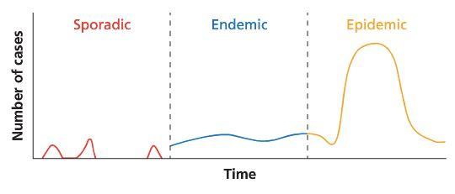

Pathogen evolution
Many pathogens evolve rapidly in a changing environment
Why Do microorganisms evolve rapidly?
—> Bacteria
- Have a high rate of division/reproduction, therefore there are many opportunities for mutations to occur
- Divide every 20 minutes

—> Virus
Genemoe copying is extremely haphazard, meaning they have a high mutation rate, as the reproductive processes are prone to more mistakes
Virus genomes may also swap parts of their genome with one another. This may create defective viruses, but occasionally something brand new will arrive (potentially with resistance)

Response to medications
- Antibiotics are applied to control a strain of bacteria
- Most bacteria are killed
- Some survive due to variation or mutation
- The surviving bacteria reproduce
- Passing favourable traits onto the next generation
- Most bacteria for this strain are now resistant to antibiotics
  - Overuse, underuse incomplete use or incorrect use will lead to the pathogens not being targeted by enough antibiotic to kill it, instead the pathogen will have enough time to learn how to kill it
  - Antibiotics thus act as a selctection pressure

Antibiotics | Antivirals
Change the structure of the bacteria’s cell wall or membrane | Bind or block receptors on the virus, preventing entry. (these receptors are what attaches the virus to the host
Disrupt the production of essential enzymes | Prevent the reals of viral contents into the host
Prevent the bacteria cells from growing by preventing protein synthesis | Inhibit virus replication

Disease management
Management strategies are used to control the spread of infectious disease including;
—> Quarantine

—> Immunisation
—> Disruption of pathogen
—> Antibiotics
—> Physical preventative measure

Questions

Heredity

1) In terms of DNA structure, explain why different alleles of a gene produce different proteins
Alleles for a certain gene have differing base sequences. These base sequences are made up of nucleotide in sets of three called codons - each codes for different amino acid which forms a protein when linked with other amino acids. Due to the different sequences of these bases, the proteins produced are different.

2) Describe the relationship between DNA, genes and chromosomes
Chromosomes and genes are made up of DNA
A chromosome is a long length of DNA
A gene is a short section of DNA/chromosome

3) How does messenger RNA determine the sequence of amino acids during protein synthesis?
The nucleotide sequence of mana occurs in 3s, called codons each one codes for a specific amino acid, the ribosome joins these among acids to form a polypeptide chain/protein.

4) What is PCR used to do?
To amplify and make multiple copies of DNA

5) List three ingredients: The dNA to be copied, single strand dan primers, taq polymerase

6) Distinguish between a gene and an allele:
A gene is a section of DNA that codes for a protein
An allele is a form of a gene for a particular characteristic having the code for a particular phenotype.

7) Describe two differences between DNA and RNA
DNA contains a deoxyribose sugar, RNA does not.
DNA contains the nucleotide thymine, RNA contains uracil
RNA is single stranded

8) List the main steps in producing a DNA profile for an animal
DNA is extracted from the animal
Short tandem repeats are amplified using PCR
The amplified samples are placed on gel electrophoresis to produce a banding pattern
(which is unique to the organism)

9) state the role of the following factors in gene cloning
Restriction enzyme: An enzyme used to cut DNA at a recognition site. It is also used to cut the host DNA in order to allow the fragment to be spliced onto the host.
Ligase: Enzyme used to join fragment of DNA to recipient DNA. Can also link to segments or complimentary strands of DNA
Plasmid: Circular shaped double stranded DNA that is not chromosomal obtained from a bacterium onto which the DNA fragment is spliced.
Plasmids are used as vectors in recombinant DNA technology.
Vector: Plasmid molecule which contains the recombinant DNA that is incorporated

Continuity of life on earth

